Inspirations

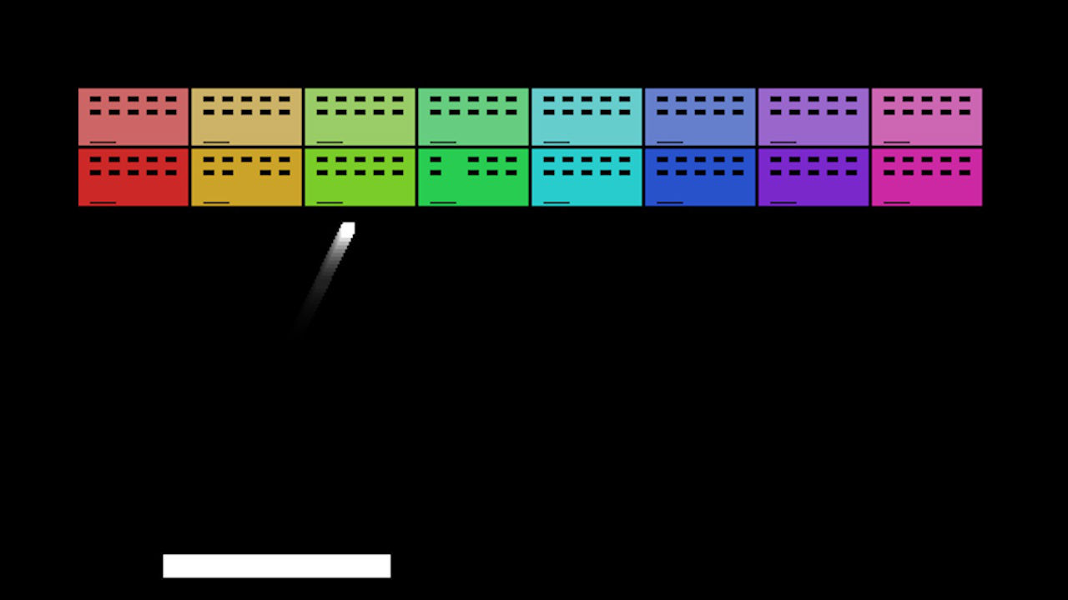

Week 10 exercise was a imitation on the retro game "Breakout"

Most of the other exercises were done with a spooky setting in mind.